Microsoft Toolkit Guide

Microsoft Toolkit is an activator that is used to activate Windows as well as the Office products. It helps you in activating both the Microsoft products which means now you don’t need to have two activators separately.

This is very light and the simplest and fastest way to activate your Windows 10. If you already own any other [**Windows 10 activator**](https://official-kmspico.co/windows-10-activator-download/)and you don’t feel comfortable with that then you must take a look at this.

It has so many additional features like it can give you the Genuine Product Keys. This tool helps you to activate the MS Products in two ways. One is by using the KMS Server method and the other is by using EZ Activator.

Also, it has both online and offline versions. This means if you have an internet connection then you can activate it by using the internet. If not then you are also able to use this awesome MS Toolkit for activation.

| **Name** | **Microsoft Toolkit** |
| --- | --- |
| Version | 2.6.8 |
| File Size | 66.07 MB |
| Requires | Net Framework 4.0+ |
| Developer | Official KMSPico |
| Category | Activator |
| Features | Windows & Office Activation |
| Downloads | 10000,000,+ |
| Updated | 1day Ago |

## What Is Microsoft Toolkit?

**Jump To:**  [show](https://official-kmspico.co/microsoft-toolkit-download/)

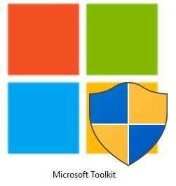

**Microsoft Toolkit is the multi-functional activator for Microsoft Office and Microsoft Windows respectively. This amazing toolkit is developed by**[**mydigitallife.net**](https://www.mydigitallife.net/)**which is an online Forum.**

It is a free tool that is made to activate MS Products. You can use it to activate Microsoft Office 2016, 2013, 2019, 2007, and so on. Instead of this, you can activate Microsoft Windows 10, 8, 8.1, 7, and vista Respectively.

It comes with two activation methods first is the KMS server mod which is used in KMSPico. If you already know about the **[KMSPico](https://official-kmspico.co/kmspico-download/)** then you must be aware that how KMS Server works.

The other method is EZ Activator, it is a process that works automatically and anonymously. It is also very safe and reliable you can choose between these two methods.

MS Toolkit also gives you Genuine product keys so if you don’t trust the KMS or EZ Activator method then you can simply activate it manually by inserting those keys.

This is the very best method which this tool provides because in other activators there is no such option available.

## System Requirements

The minimum system requirements for using Microsoft Toolkit is given below:

* You must have Pentium 3 or Above
* Minimum 1GB of RAM is Required
* 30MB of Hard Disk Free Space
* Must Install .NET Framework 4.0 or Above

These are the minimum requirements for this tool, you must have these on your computer to install and use it. Otherwise, you may face a problem or this tool behave strangely. Before installing make sure you have these on your PC.

Microsoft Toolkit Supported Products

If you don’t know what products are supported by this toolkit then you must check out this list. It is the full list of the products which MS Toolkit supports.

Read the list below before trying to activate any version of Windows or Office

|  |  |  |
| --- | --- | --- |
| **Operating Systems** | **Office** | **Windows Servers** |
| All Versions of Vista | Office 2003 | Windows Server 2008 |
| All Windows 7 Versions | Office 2007 | Windows Server 2008 R2 |
| Windows 8 Editions | Office 2010 | Windows Server 2012 |
| Windows 8.1 All Editions | Office 2013 | Server 2012 R2 |
| Embedded Windows 8.1 | Office 2016 | Windows Server 2010 |
| Windows 10 and All Editions | Office 365 |  |

## Download Microsoft Toolkit 2.6.4

Have you just read about the Microsoft Toolkit and all its features? Now, are you curious to download this awesome activator? Then your wait is over  here is a guide on how to download MS Toolkit from our website.

[**Download Microsoft Toolkit**](https://official-kmspico.co/download-ms-toolkit)

First of all, you need to click on the Download button which is provided below this guide. After clicking on that you will be redirected to the Download page.

Here you will see a Download now button just click on that button then you will see a Mediafire link. In Mediafire just click on the download button and wait for a few seconds your download will be started automatically.

Now choose your destination folder where you want to download your file (I recommend choosing Desktop as it makes it easy to find that file).

That’s all now you have successfully download MS Toolkit on your computer. Now it’s time to know how you can install it. Because installing it is a little bit different as you have to do some steps before installing it.

## How to Install Microsoft Toolkit

Let’s now check out the below step by step guide to install Toolkit properly on your computer. You must follow all the steps carefully to avoid damaging files or your computer.

Read every step very carefully and two times so you don’t forget what you need to do.

Ok, now let’s move to the guide:

Before installing or extracting the Toolkit make sure to **disable your antivirus** (It is because Microsoft has blacklisted such activators, in that case, your file will be removed and antivirus shows you that it is a virus).

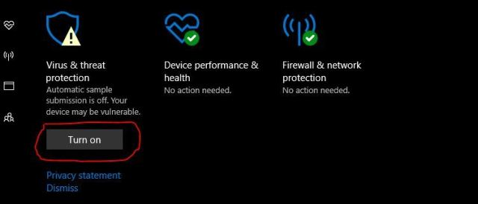

After disabling your antivirus now it’s time to extract the MS Toolkit (It will be password protected Click Here To See Password).

**Step 3:** Ok, so when you extract the files you will see a folder with the Name of **Microsoft Toolkit.** Open that folder and then double click on the icon, it will ask you for permission just allow it.

**Step 4:** After that you see the installation Windows appear. Just follow the steps which are shown in that windows and your installation will be started.

That’s it you have now successfully installed Microsoft Toolkit on your computer. You can find it on your **Desktop** or from the **Start Menu.**

Ok, so this is the simplest and easiest guide to Install Toolkit on your computer. Now comes the main part of this topic which is how to activate Windows and Office by using Microsoft Toolkit.

Before we proceed first of all read the below guide to temporarily disable your antivirus if you don’t know how to do it. So, if you won’t disable it you will be unable to install it or maybe your file gets removed from the computer.

## Temporary Disable Antivirus

Here is the list of the most famous Antivirus and the way to disable them. You can check out here otherwise you can search on Google for the antivirus you are using.

### Temporary Disable McAfee

* First, you need to look at the right side below in the taskbar, you will find the M icon in the system tray.
* Right-click on the **“M”**icon and choose the real-time Scanning. It will be located on the top of the menu under the green banner. By default, it is on.
* Now you need to turn it off when you click on it off it will ask you for how long you want to turn it off. Choose the time according to your choice and turn it off.

### Temporary Disable AVG

* Open the AVG software, by clicking on the AVG icon located on the desktop or through Start Menu.
* In AVG Window you will see there is an **“Option”**button is located top right corner.
* Click on the options and you will see the options list there. Now simply click on the **Advanced Settings.**
* You will then see a new window will pop-up. Now you need to go to the **Temporary Disable AVG Protection.**It can be located on the left side menu.
* Then you will see there is a button labelled as **“Temporary Disable AVG”.** Just click on that button and it will ask you how long you want to disable it.
* Choose the desired time and click on **OK,**then your antivirus will be disabled for a specific time

### Disable Webroot Antivirus

1. To disable webroot Antivirus move to the right side of the taskbar and look for the Webroot icon.
2. Right-Click on the icon and then click on **Shutdown Protection.**
3. Now you will see a prompt message appears for confirmation. Just click on Ok and it will be disabled.

**Note:**

***Maybe it will ask you to enter the Captcha depending on your settings***.

### Disable Windows Defender

To disable the Windows Defender you first need to open **Start Menu** and then Go to **Settings.**

In settings open **Update & Security** and then go to **Windows Security.**

From there you need to open **Virus & Threat Protection, &** then **Manage Settings** or (**Virus & Threat Settings** if you are using an older version).

Now you just need to disable the **Real-Time Protection.**It will show you a warning just ignore it and click Ok.

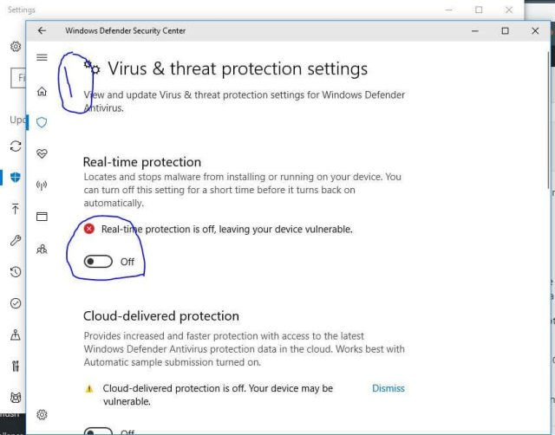

These are some most famous Antivirus which are mostly used among individuals. Now let’s move to the activation process of Office and Windows.

## Activate Windows Using Microsoft Toolkit

So, finally, you have successfully downloaded and installed the Toolkit on your computer. But still, don’t know how to operate it and how to activate your Windows using Microsoft Toolkit Activator.

Then don’t worry here is a simple and easy step by step guide to activating your windows for the rest of your life using the MS Toolkit.

First, you need to open Toolkit as an Administration. To do so **Right-Click** on the icon and then choose **Run as Administrator.**

Now you will see a new Windows pop-up. In that window click on the Windows icon located on the left side.

After that, you will see another Windows with so many options. You need to go to Activation located above, and choose the **AutoKMS** from the drop menu, and click on install.

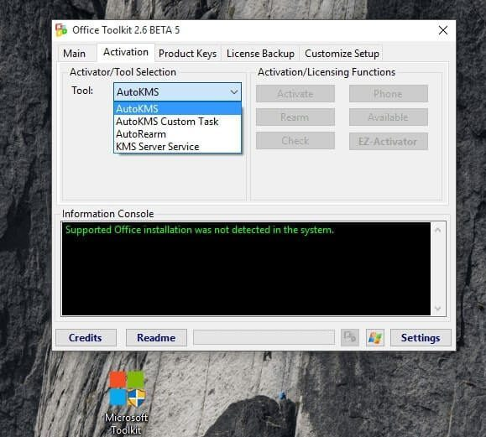

When you installed AutoKMS now right-click on My Computer and then check which Windows edition you are using.

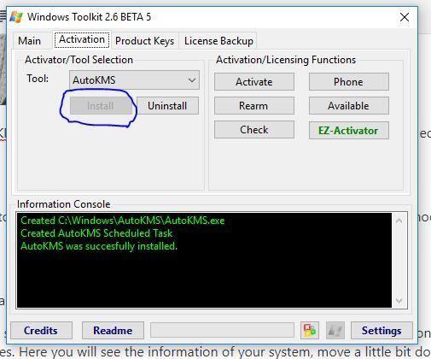

After checking you need to go Product keys and then Select your Windows Version, and also choose the edition of your Windows.

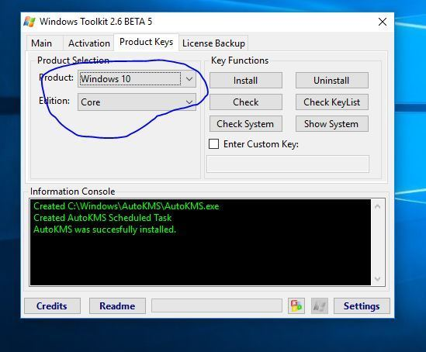

**Step 6** – Now just click on the install and your product key will be installed in your system.

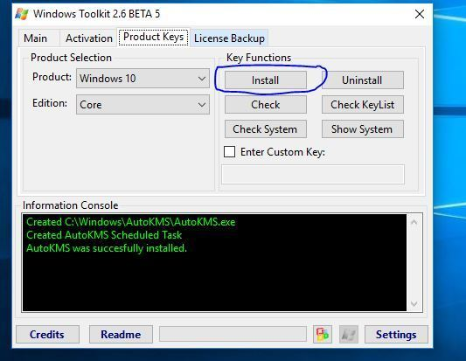

After following the above step now you must restart your system. Now you need to right-click on My Computer and then open Properties.

Here you will see the information of your system, move a little bit down to check the Windows status.

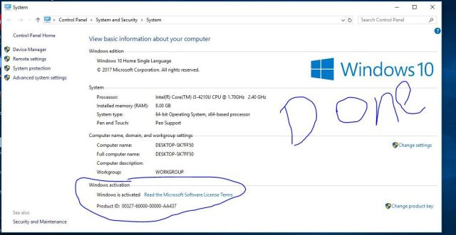

Instead of this, you can simply activate it by using the **EZ Activator** method. You just need to open the program as **an Administrator** and then clicking on the **Windows** icon and after that click on **Activation** and then choose the **EZ Activator.**

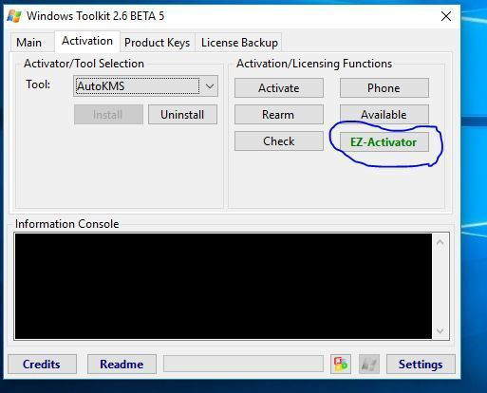

That’s it you have successfully activated your Windows.  Don’t you think that is was the easiest method?

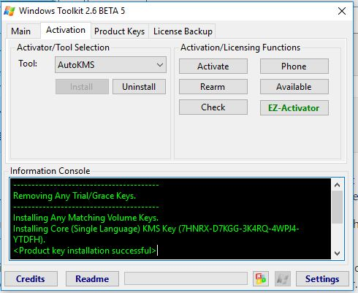

**So, now let’s move to the activation process of Microsoft Office.**

## Activate Office With Microsoft Toolkit

Ok, so nowhere is the guide for activating the Office:

**Step 1** – Open Microsoft Toolkit as an Administration and then you will see a new Pop-up Windows.

**Step 2** – From that pop-up window click on the **Office logo** which can be found left-side below.

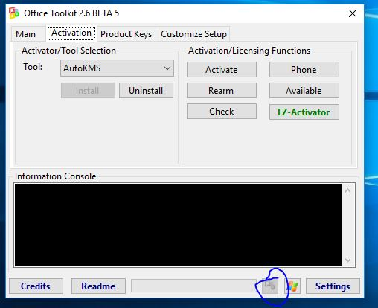

**Step 3** -Then you will see another activation windows will pop-up. In that window choose the Activation from the tab menu above.



**Step 4** – Now you just need to click on the EZ Activator and wait for a few seconds until the process completes.

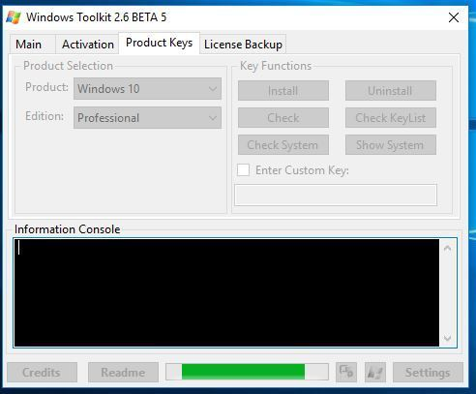

After you see the Completed or Success message in the Information console. Just close all the windows and restart your computer.

When your PC boots after restart now open any product of office and click on **Files** and then from the left menu choose **Account.**

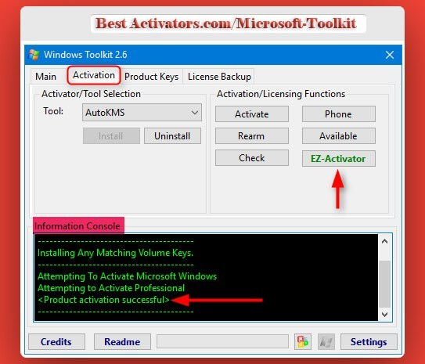

Now you can see the activation status there. If you see it says your office is not activated then you can simply follow the above steps again and then you will get your office activated successfully.

## Features Of Microsoft Toolkit

Ok, now you have just read about the Microsoft Toolkit and its features. Now it is time to learn what features does actually this tool provides?

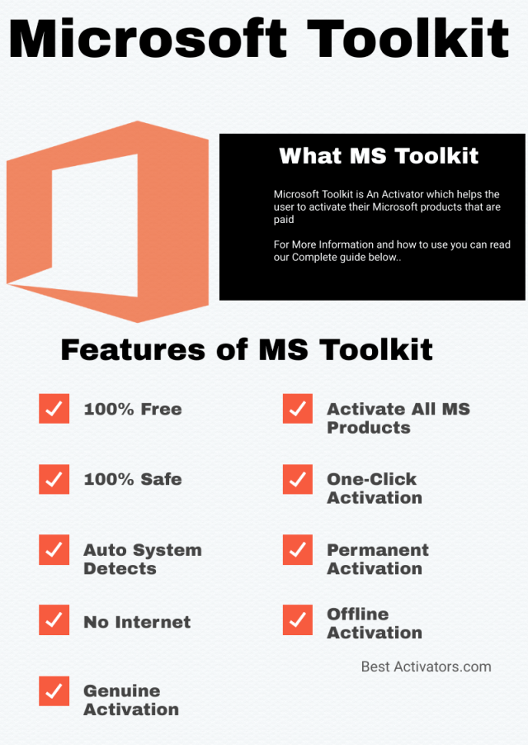

Here is the complete list of features that you get after using it:

**Windows Activation**

When you are using MS Toolkit you will be able to activate your Windows Operating System. It will allow you to activate Windows 7 to Windows 10 also it can activate all the editions of Windows.

**Office Activation**

Instead of only activating Windows this amazing activator helps you in activating the MS Office products. You can activate any version of Microsoft Office starting from 2003 to 2016.

**Genuine Activation**

It gives you the guarantee for Genuine activation. Now you don’t need to worry about being caught by Microsoft or don’t ever think that they will mark your Windows as flagged. It is 100% Genuine and 100% secure.

**Multi-Module**

It has multi-modules which means that it supports the multi activation method. Such as, activating Windows or Office through the **[KMSAuto](https://official-kmspico.co/kmsauto-net/)**method or activating Office or Windows by using EZ Activator. You can choose your desired module to activate your Microsoft Products.

**N-Bit Supports**

It is supported by both processors, no matter if you are using a 32 bit based processor or a 64-bit based processor. You can activate and use this tool for both architectures without any issue.

**Online & Offline Activation**

If you are using the old version of Microsoft Toolkit then you must know that it requires to have an internet connection. But in the latest and updated version, they have added the ability to work offline.

Now when you download the latest version of MS Toolkit from the link which we have provided. Then you don’t need to have an internet connection to use it, you can activate your MS Products totally standalone.

**Auto Detect System**

The Auto-Detect System is the best feature of this activator. It means that now you don’t need to choose your system the activator will automatically detect it and you can then see the information in the Microsoft Toolkit Window.

I love MS toolkit only for this reason because whenever I install fresh windows I rarely forget which edition I just installed.

**Live Notification Alerts**

This service helps you to notify you that your Windows or Office is activated. It means that when you click on the activate Windows, you can then do any other task and when your windows are activated. You will be notified with the live Notification alerts.

**Virus Free**

Microsoft Toolkit is scanned by Virus Total and other Virus scanners and it is proved that it doesn’t contain any type of virus. It is 100% virus-free and there is no such Malware and Trojans found in this activator.

**No Advertisements**

Microsoft Toolkit doesn’t contain any type of advertisement. This tool is 100% free and it doesn’t promote ads, so whenever you use and activate Office or Windows us MS Toolkit then you won’t get annoyed by the ads.

## Frequently Asked Questions (FAQs)

Have you just read the features of Microsoft Toolkit and also installed and activated your Windows. But do you still have some questions in your mind which you want to ask?

Then there is the list of some most asked questions by the people around the internet. I have collected some of the questions which are asked mostly from Quora and other QnA forums.

Check out this list maybe you also find the answer which you are looking for. Otherwise, if you are unable to find you can simply ask me in the comment section or by filling the Contact Us form.

I will be very glad to listen from you as well very happy to help you

### Q1) Does this Microsoft Toolkit steal my personal files?

Never, it will never ever steal your personal files as it doesn’t access your Hard Disk nor it ask you for that permission.

It only accesses the system files which are used to activate Windows. So, don’t worry about your files they are 100% safe and secure.

### Q2) Can I activate XP Windows using MS Toolkit?

Yes, sure you can activate Windows XP by using this toolkit. If you are unable to activate it using the EZ Activator Method or AutoKMS then you should select Product keys and then choose your Windows Version and the Editions. Now just click on install and the keys will be installed in your Windows OS.

### Q3) Are there any other alternatives to Microsoft Toolkit?

Yes, there are so many alternatives are available such as KMSAuto Net, KMSPico, Windows Loader. You can find the most famous and the best alternatives from my website.

### Q4) I read somewhere that Microsoft Toolkit has a Virus? Is it true?

No, these are only rumours which people are spreading. There is no such virus and malware found in this Activator.

If you are downloading from other websites then I am not sure about that, but the file provided by me is 100% safe and I personally used it.

### Q5) Do I need to have an internet connection to use this activator?

If you are using an older version then you must be connected to the internet as it doesn’t work offline. But if you are using the most recent version of MS Toolkit then there is no need to have an internet connection.

It works the same as the online version. You can also use the internet if you want to but there is no such requirement after the latest update.

## Conclusion

**Microsoft Toolkit** is just a Gift from Team Daz. This activator is just amazing and the two in one feature is the best feature that I love about it.

If you have just skipped the Features list then please first check out the Features before you processed. You won’t believe what awesome features this tool is providing to its users.

Also, if you just skipped the installation process then check that also, because there are some steps that you must follow. Otherwise, if you won’t follow those steps you face problems during installation.

This tool is basically used when you don’t want to buy a genuine copy of Windows or Office. In some cases, most people can’t afford money for the original copy.

That’s why this activator is very helpful and you just need to have it to activate windows or office.

If you just like my article please share it with your friends, because the share is care. Also, enable the Push Notifications so whenever I update or post something new you get notified.

You will get the latest updates on this tool right from my website. This means you don’t need to go to another website to download the updates.